SOFTWARE ENGINEERING – CSA1020

Name: Deepalakshmi S
Register Number: 192511379

EXP- 8
ONLINE LEARNING PLATFORM – MOSCOW & KANO
Aim
To categorize and prioritize platform requirements.
Procedure
1. Create Jira backlog.
2. Add all 6 features.
3. Categorize using MoSCoW.
4. Classify using Kano.
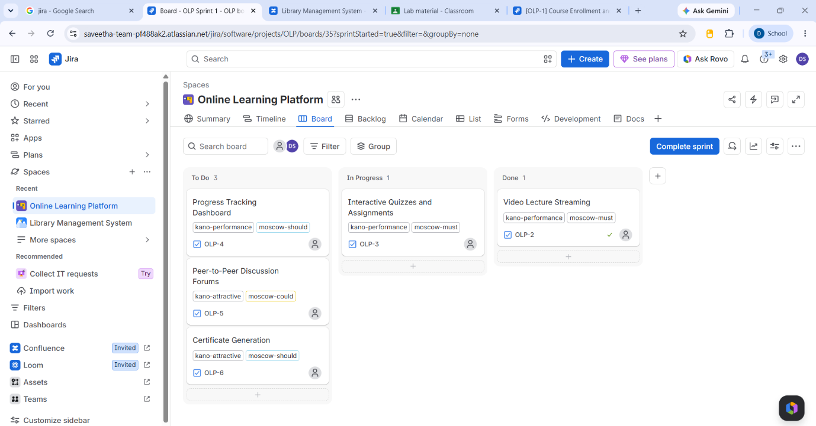
5. Prioritize accordingly.
